Panda3D MacOS Installation Guide

This is a step-by-step guide for installing and using Panda3D on Macs. It was tested using MacOS Ventura on Apple Silicon, but should work on Intel Macs as well. Any version numbers listed are the most recent at the time of writing this guide, if more recent versions have been released it is recommended to use those. This guide will walk you through setting it up with Visual Studio Code, however you are able to use any python editor you prefer (you will just have to set it up yourself.

There are 5 steps to this guide:

1. Install Python
2. Install Panda3D
3. Install VSCode
4. Create First Project
5. (Optional) Full Autocomplete Functionality

**Step 1: install python**

**Step 1.1: Download Python**

Go to <https://www.python.org/downloads/> and download the latest version of python (python 3.x.x)

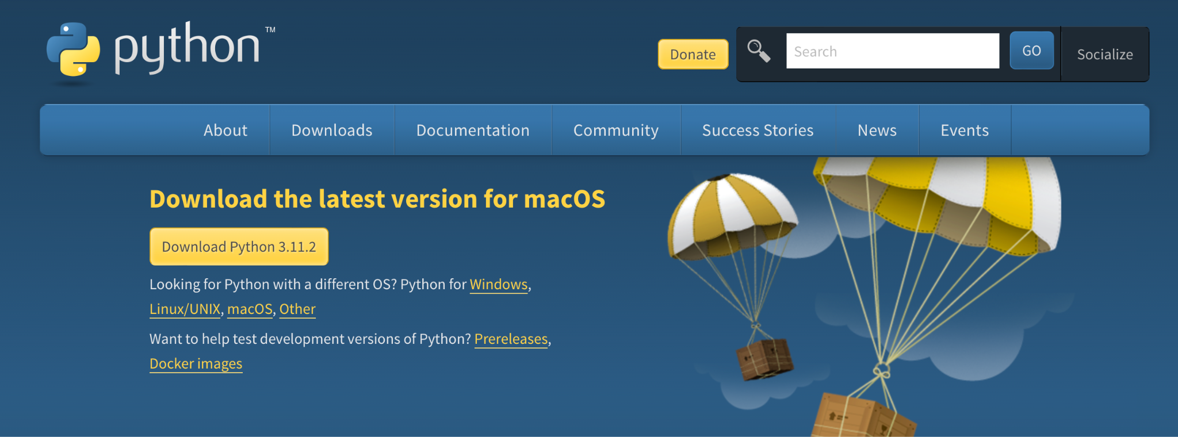

**Step 1.2: Install Python**

Click on the Python installer in the downloads folder and go through the installation

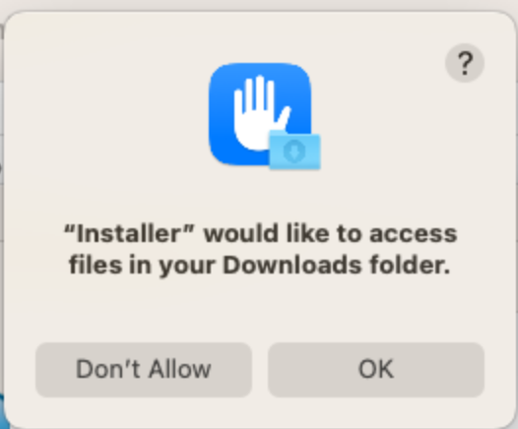

Click Ok

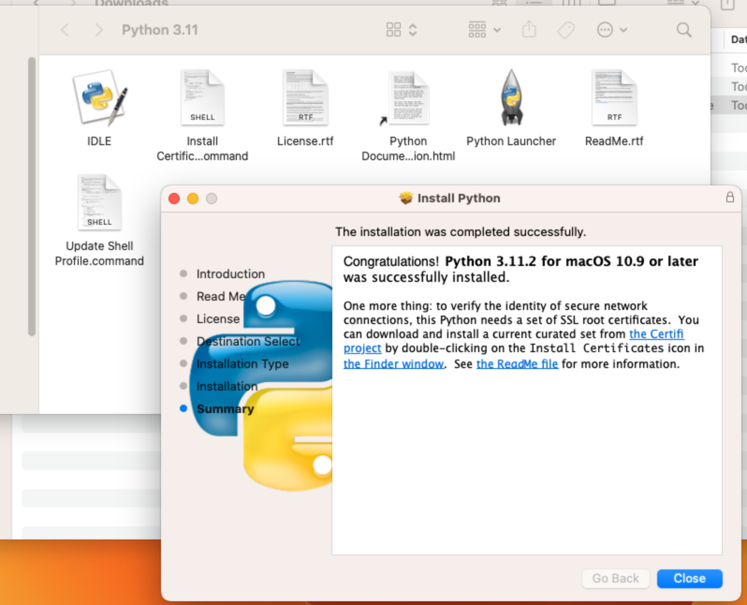

Once it is installed, **Restart your Mac**

**Step 1.3: Check if python is installed**

Open Terminal: Search Terminal in Spotlight (cmd + space)

Copy the following command and press enter: python3 --version

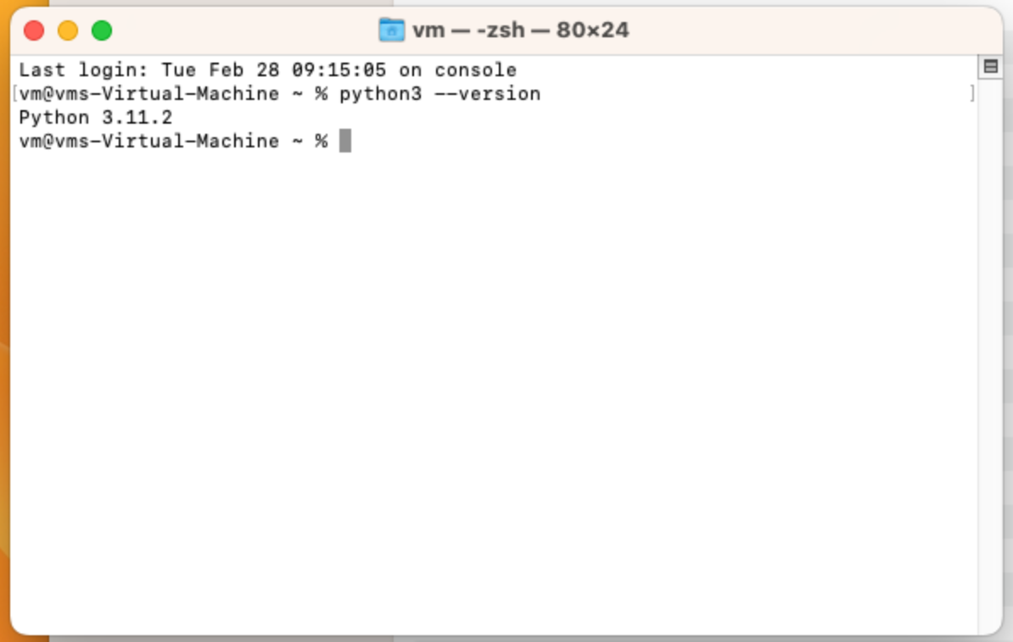

It should display the version you installed

**Step 2: install Panda3D**

**Step 2.1: Download Panda3D**

Go to [https://www.panda3d.org/download/](https://www.panda3d.org/download/sdk-1-10-13/) and download the latest version of Panda3D (SDK 1.10.x)

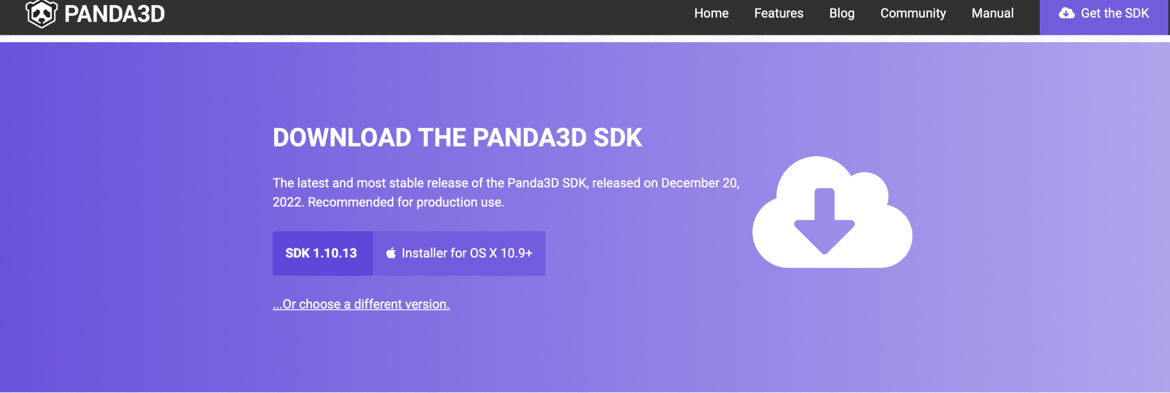

Click on installer for OSX 10.9+

**Step 2.2: Install Panda3D**

Click on the Panda3D installer in the downloads folder

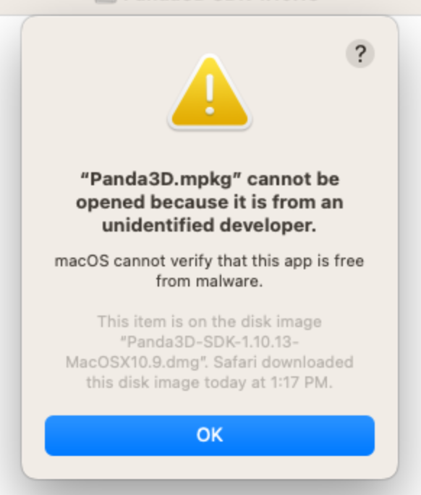

If you this error, go to the downloads folder and right click on the installer, then press open

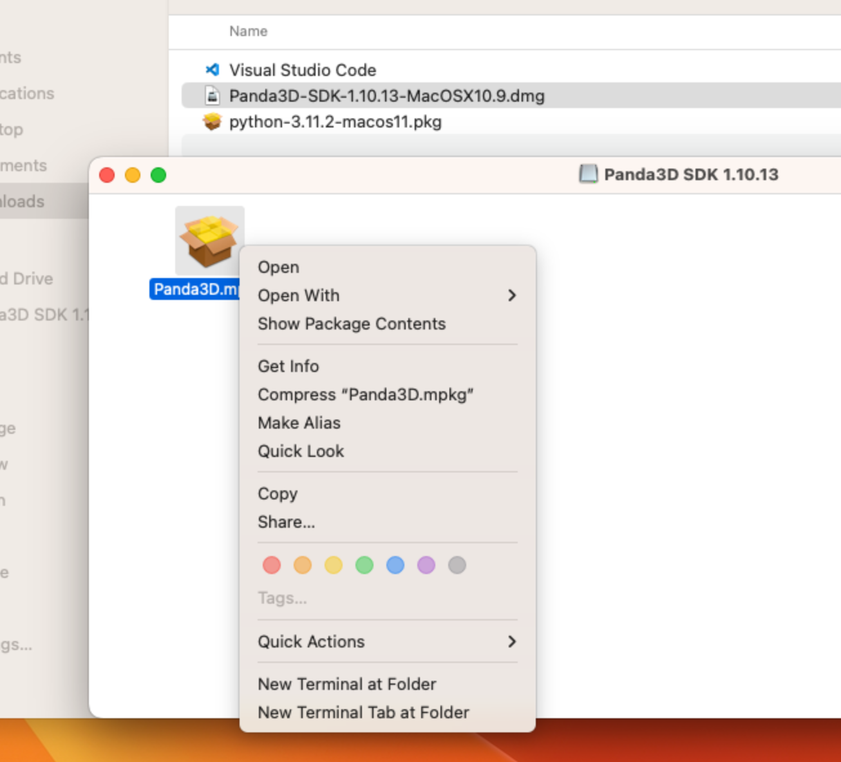

Click on “Open” at the very top

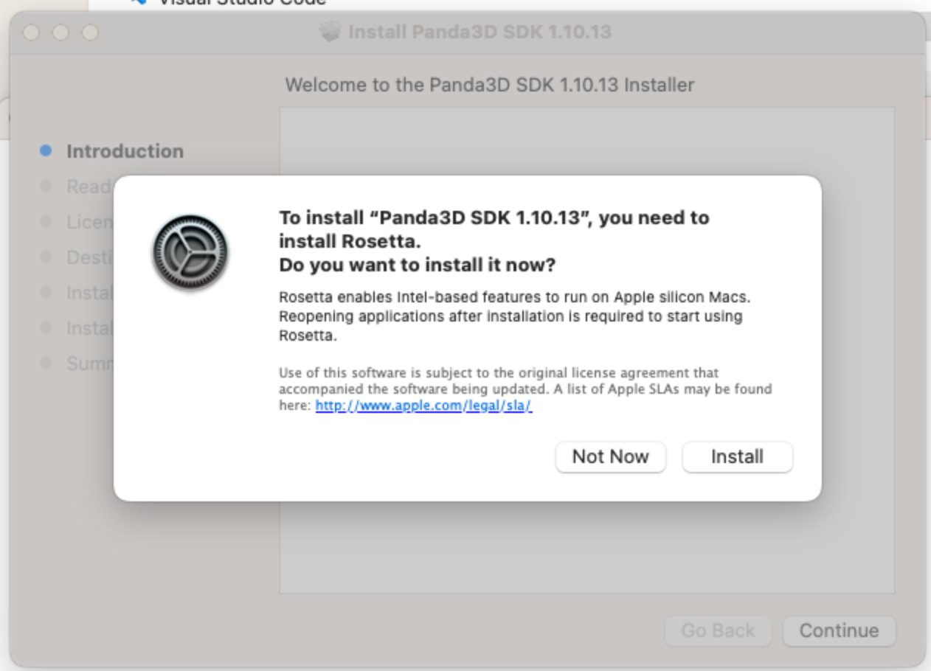

**Apple Silicon Only:** Click “Install” if your Mac prompts you to install Rosetta, this is a translation layer for you Apple Silicon Mac and must be installed for Panda3D

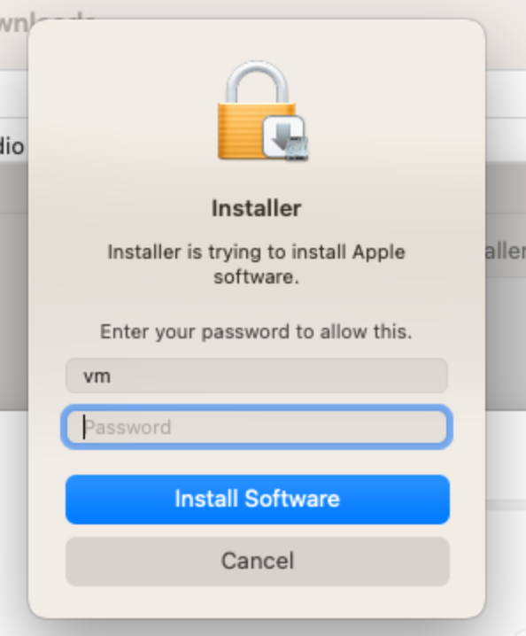

Enter your password and install

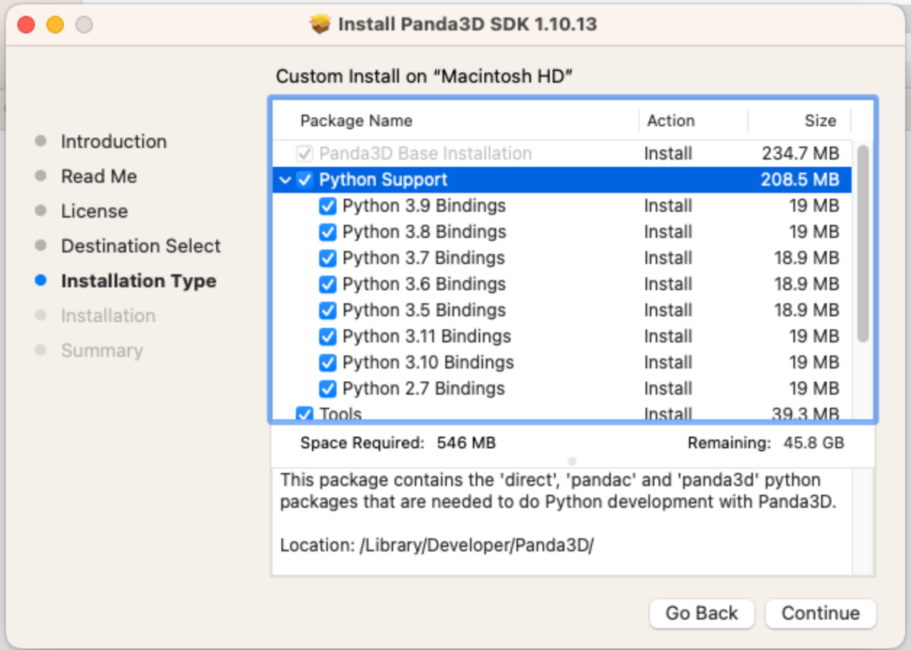

When you get to “Installation Type” **check Python 3.11 Bindings**

Once it is installed, **Restart your Mac**

**Step 3: install VSCode or another editor of your choosing**

This tutorial and later tutorials of the course will use Visual Studio Code, you may use any code editor you prefer, but you will have to set it up yourself.

**Step 3.1: Download VSCode**

Go to <https://code.visualstudio.com/Download> and download .zip **Intel Chip** (Very important **do not download Apple Silicon** even if you have it, otherwise Panda3D will not work)

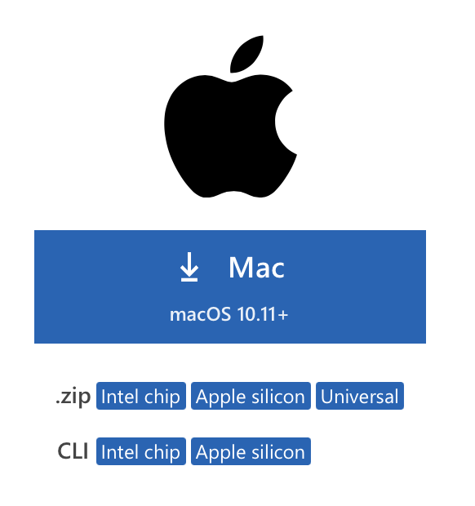

Download .zip **Intel Chip**

**Step 3.2: Install Visual Studio Code**

Click on the “Visual Studio Code” application in the downloads folder

Once opened, click on the extensions icon (cmd+shift+x)

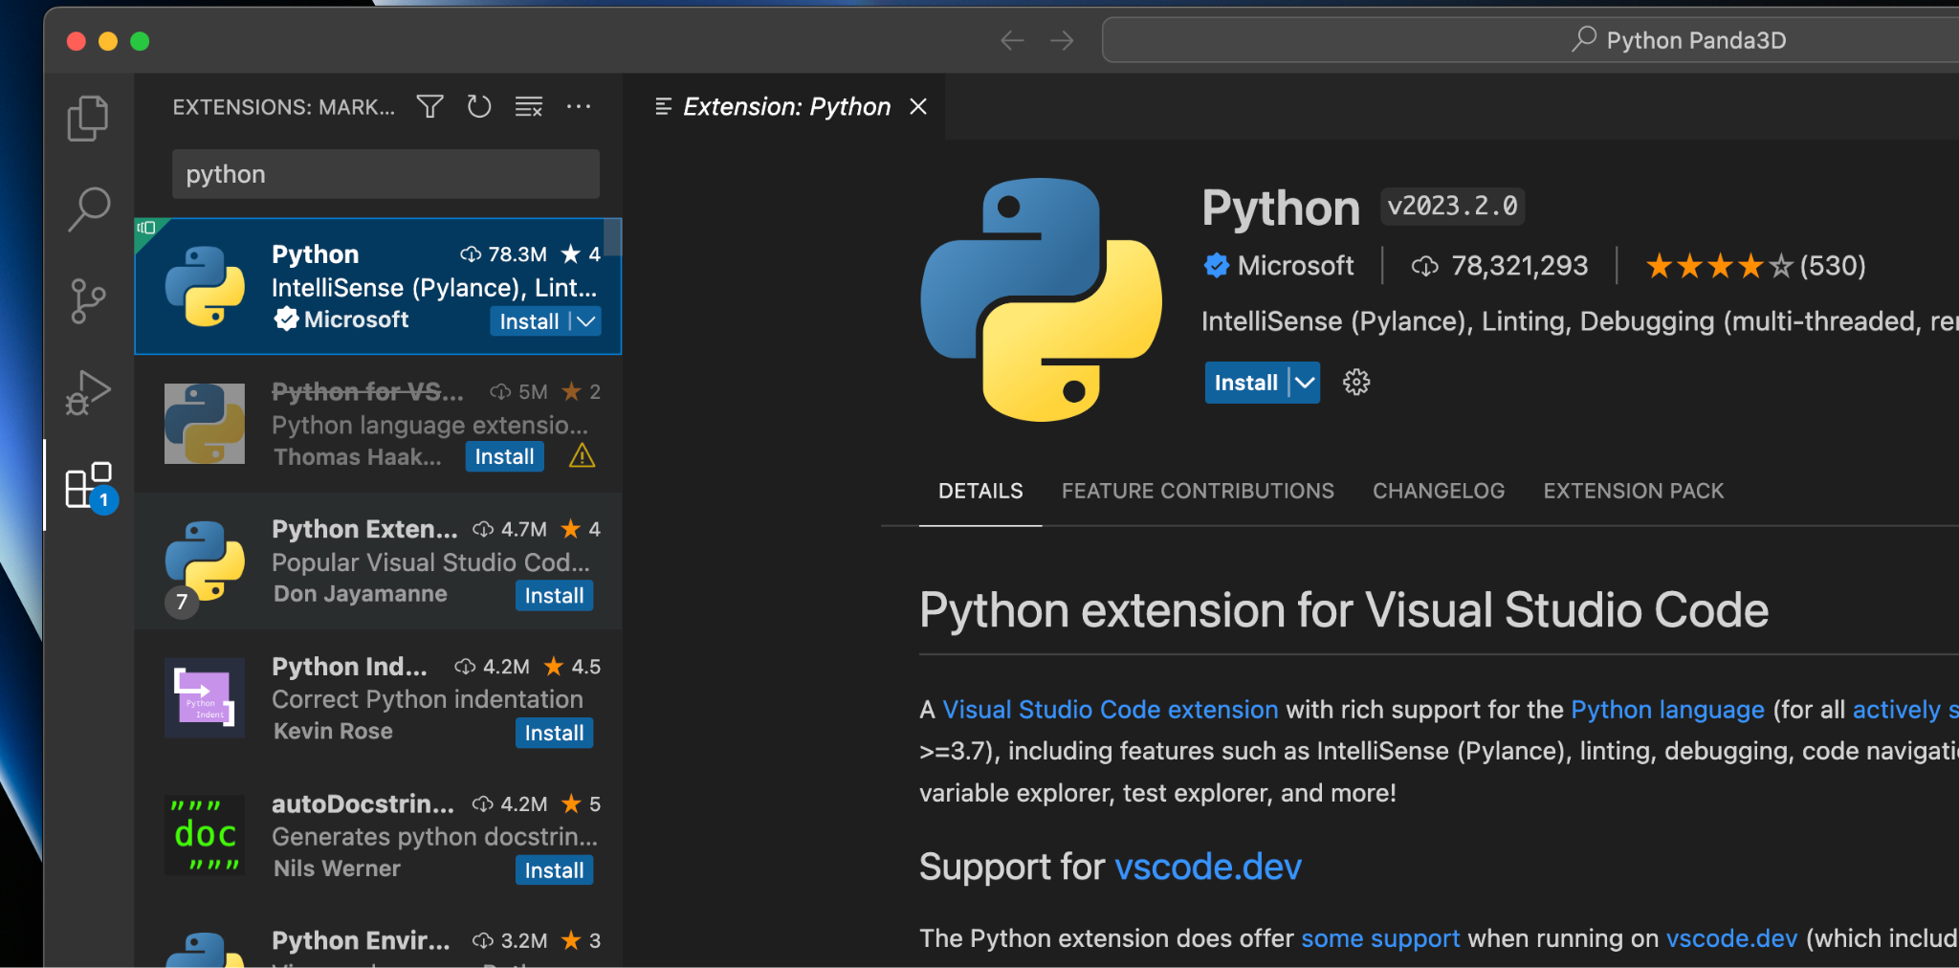

Search Python in the search bar, click on “Python” and install the extension

Feel free to install any other extensions you find useful, the “Python Extension Pack” with 7 extensions is recommended

**Step 4: Make a Panda3D Program**

Make a folder for where you want your code to be

Open VSCode and click File > Open Folder on top menu bar and select the folder that you just created

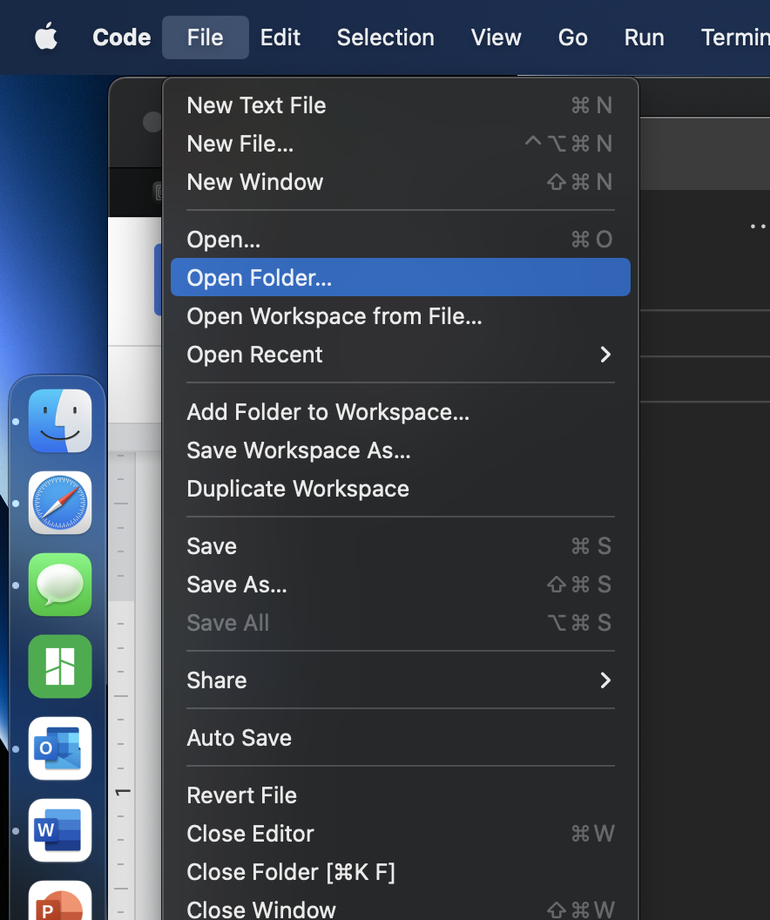

Make a file named test.py

Paste this code into it

from direct.showbase.ShowBase import ShowBase

class MyGame(ShowBase):

def __init__(self, fStartDirect=True, windowType=None):

super().__init__(fStartDirect, windowType)

game = MyGame()

game.run()

Click Run (Triangle icon on the top right)

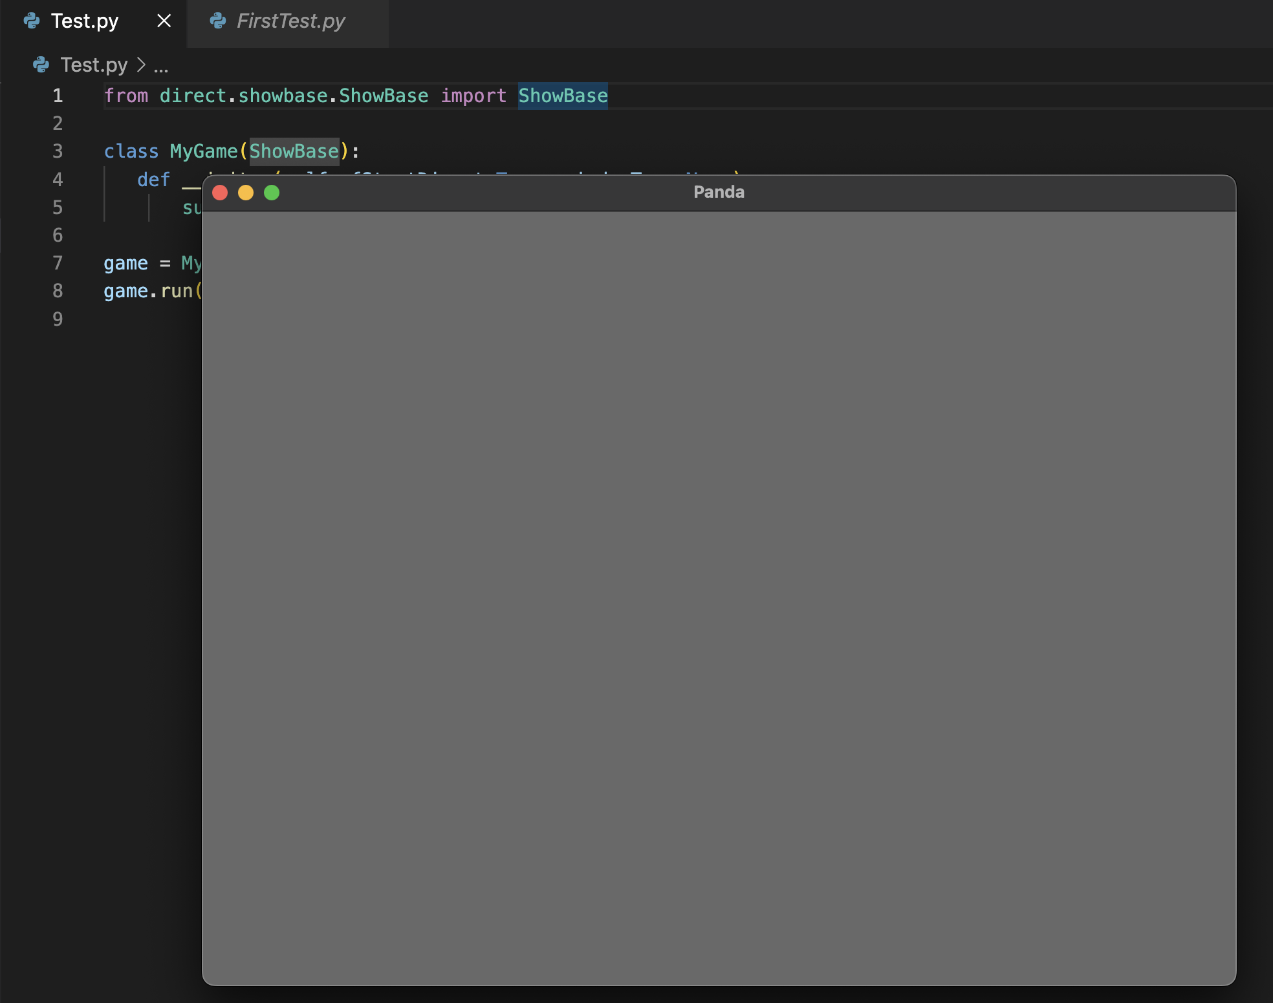

A grey box should open

**Step 5 (optional): Install autofill functionality**

While Panda3D is completely functional at this point, you can add additional functionality to make it slightly easier to develop programs. For example, if you type in:

**from** **panda3d.bullet** **import** b

There will be no prompt with suggested completions to this line. It is possible to have it recommend a list of everything you could complete this line with, if you want this, you will have to do the following:

**Step 5.1: Open Terminal**

Search Terminal in Spotlight (cmd + space)

**Step 5.2: Download Autofill Files**

In Terminal, paste in the following command and hit enter: python3 -m pip install --upgrade types-panda3d

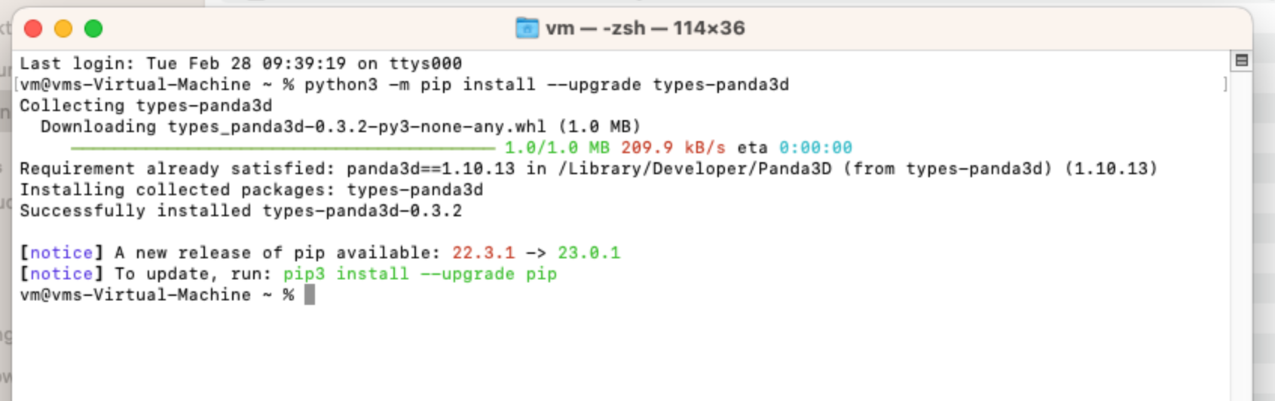

**Step 5.3: Find and copy the location of the downloaded files**

In Terminal, paste in the following command and hit enter: pip3 show types-panda3d

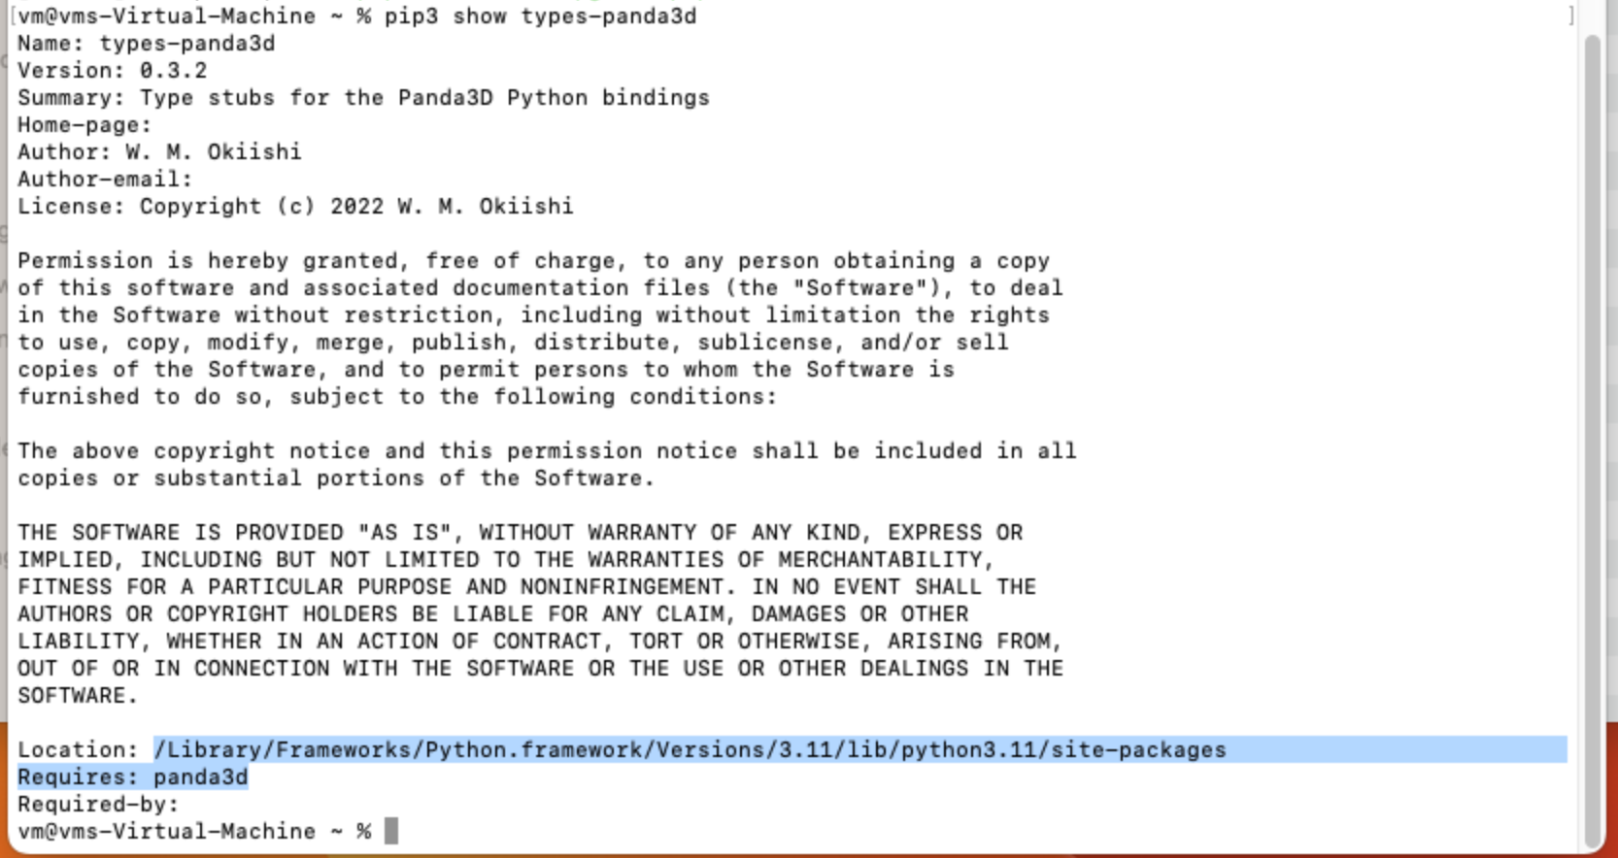

Scroll down until you see “location”, it should look something like /Library/Frameworks/Python.framework/Versions/3.11/lib/python3.11/site-packages

Highlight and copy the location

**Step 5.4: Link the location in VSCode**

Open VSCode

Click on the settings(gear) icon in the bottom left corner and click on “settings”

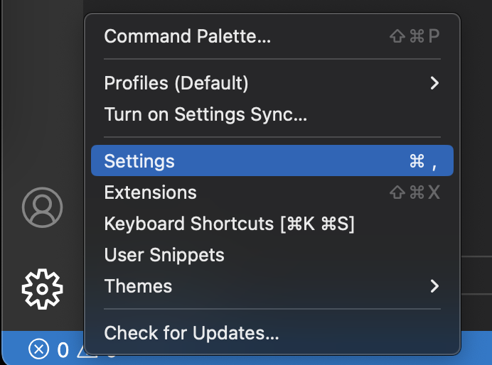

On the top search bar, search “extra paths” and select “pylance” on the left under the “user” tab

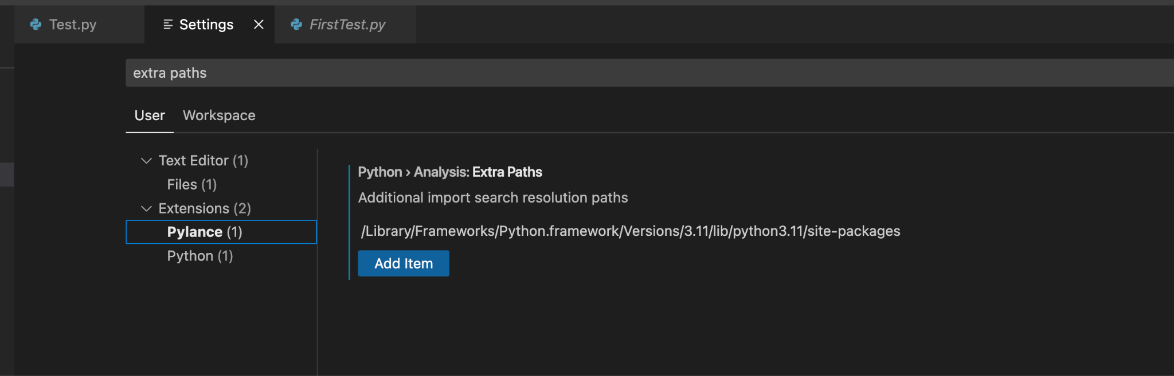

Click on “Add Item” and paste in the path that was copied in step 5.3

Press “OK”

**Step 5.5: Verify that the autocomplete is working**

Open the test.py file created in step 4

Under the line from “direct.showbase.ShowBase import ShowBase type”

input “from panda3d.bullet import b”

It should show a list of autocomplete suggestions

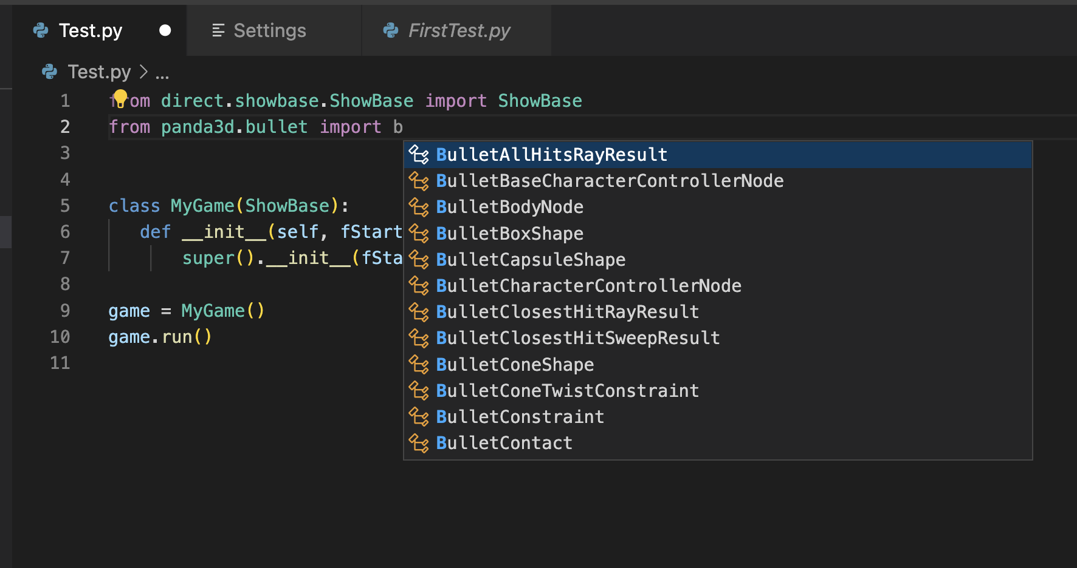

Congratulations, you have successfully installed Panda3D on your Mac